**Asus Aimesh Router Setup**

Facing slow or dead spots at the remote corners of your place? Need a permanent solution to resolve this issue?

Asus Aimesh Network can be a perfect solution for your situation.

Asus Aimesh spreads your existing Wi-Fi network through multiple nodes in your home. It’s a great way to fill up the dead spots and expand the Wi-Fi coverage over a larger area. However, the [**Asus AiMesh router setup**](https://www.aimeshroutersetup.com/) requires a little more effort than a traditional router setup. The following steps will help you set the things up.

AiMesh is an ultimate feature that allows you to connect multiple Asus routers to create one whole-home Wi-Fi network. You can say goodbye to unreliable and unstable Wi-fi signals with the [**Asus AiMesh setup**](https://asussetup.com/). The AiMesh network lets you upgrade without throwing away your old or traditional router.

This guide is made to teach correct steps on how to set up AiMesh network without any hassles.

Things you should keep in mind for [**Asus router mesh network setup**](https://asusrouterguide.com/asus-router-login/):

* Evenly place Asus routers covering the entire place
* The ideal distance between routers should be 10-15 meters.
* Keep your AiMesh hubs away from obstructions like- cordless phones, Microwave ovens, and wireless signal sources.
* Make sure obstacles such as big furniture, metal objects, thick walls, or bricks are not blocking the connection.

**How to set up AiMesh network?**

* Install the latest firmware
* Set up the primary router
* Search for AiMesh nodes
* Add nodes to AiMesh network

The [**Asus Aimesh router setup**](https://www.aimeshroutersetup.com/blog?id=19) is different from the regular setup but it is not difficult at all. You can choose setting up Asus AiMesh on the web GUI or Asus app on your mobile phone. Before you begin with the setup process, you must prepare:

* Two Asus routers
* Assign one as the main router and the other one as the node
* Place the router and node within 1-3 meters for the installation part

To begin with the [**Asus AiMesh setup**](https://asusrouterguide.com/), you need to update the router to the AiMesh support firmware. Connect your computer to the Asus network using an ethernet cable. Visit [**router.asus.com**](https://routerasus-login.com/) to download the latest firmware and download the latest firmware automatically.

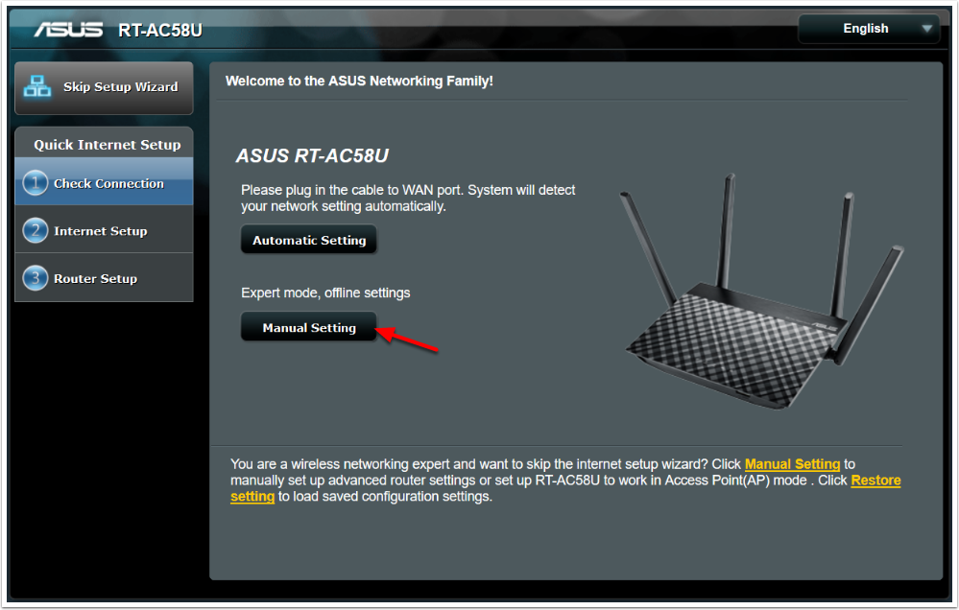

For the next step, you need to reboot the [**Asus node to the default settings**](https://routerasus-login.com/asus-router-login/). Once the reset process is done, keep the node powered on and standby for the Asus router mesh network setup.

Further, you would require to set up your primary router. It can be done with a web-browser of using the Asus app. After setting up the primary router, you can add the node to your AiMesh network. Once you receive a message saying that the synchronization between the Asus router and node is completed, you can proceed to the next step.

Finally, place your Asus node to a new location. It is recommended to place the node in between your AiMesh router and area with dead or dropped wifi signals.

If you encounter an issue with the [**Asus AiMesh router setup**](http://www.routerasuss.net/), you can get back with our technical team and ask for their help. Our in-house technicians are available round the clock to help you with the [**Asus AiMesh setup**](https://routerasus-login.com/how-to-setup-an-asus-router-instantly/).